Game.

Need:

Drawings:

Objects in a house

Player

Clothes

Armer

Wood/nails/building

Food

Water

Zombies (multiple kinds)

Cars/outside

Way to make/generate multiple houses

Tech tree objects -

Code:

Player movement

Zombie path finding/AI

Tech tree – some will cause time and research

Timed defense - after noise level can cause another wave

Day/night cycle

Timer

Inventory

Classes:

Player – inventory

Zombie spawned– randomizer that increases in selections as days go by and increase Max zombies at time per day

Types: Regular, Boomer, strong arm, armored (swat),

House(s)

Items/ weapons, food, water

Time

Drawing?

<https://www.pixilart.com/draw>

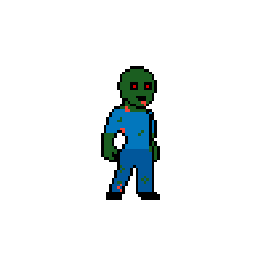

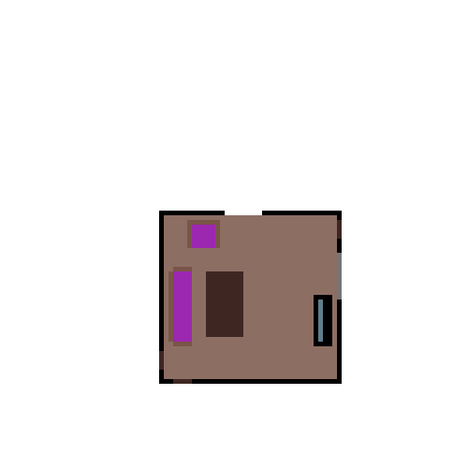

Pygame

Pygame - pseudo-3d games (like doom)

Make a 3D engine with python from scratch or use one called ursina Engine

(Would take time if I do, but if one of u can do it that would be great)